CARESTREAM HEALTH
Delete or hide all instructions. Table of Contents Page should be the first page of the document.
This template combines aspects of both software high-level and software low-level templates. For designs of narrow scope, an iterative process may be used where a high-level design is recorded first, followed by a low-level phase that expands on the original content. For complex projects, this template may first be used to record only a high-level design. Low-level design details can be recorded in separate documents also created from this template, which refer back to the high-level design document. Project teams should feel free to expand subsections as necessary but please retain the original upper-level section headers for consistent presentation.
Embedded software teams may adapt this template for procedure design. It is fine to combine object oriented design and procedure design in one document or have separate documents.
There will be sections in this document that may not be appropriate for your use, or may not be needed right away. If you do not use a section, do not delete it. If a section does not apply to your design, please enter “N/A”. If a section will be completed in a later design phase, please enter “TBD”.
To use this template: think of a descriptive title and save the document under that title in your source control provider. Then obtain a part number. Fill in the part number and title on this Title Page. Then work through the rest of the template adding the information required for each section. Some sections already have some boilerplate information that you may use or modify. Some of the boilerplate is just an example and will need to be edited.
Change History
Revision | Description of Change | Revision Date
0.1 | Initial draft | 3/15/2015

Table of Contents
1 Introduction 5
1.1 Purpose 5
1.2 Scope 5
1.3 References 5
1.4 Abbreviations/Acronyms 6
1.5 Acronyms 6
1.6 Meanings 7
2 Requirements Analysis 7
2.1 Critical Assumptions/Risks 7
2.2 Requirements 7
2.3 Other Requirements 7
3 Use Cases 8
3.1 Actors 8
3.1.1 Service Provider 8
3.1.2 TSC Engineer 8
3.1.3 Manufacturing User 8
3.1.4 QA Engineer 8
3.1.5 Design Engineering 8
3.1.6 Technologist (customer) 8
3.1.7 Key Operator (customer) 9
3.1.8 Application Consultant 9
3.2 Use Case 1 – Connection of the Remote Exposure Device and Capture Console 9
3.3 Use Case 1 – Connection of the Remote Exposure Device and ROP 10
3.4 Use Case 2 – Loss of connection between the Remote Exposure Device and Capture Console/ROP 11
3.5 Use Case 4 – Remote Exposure Device sets/gets info for a Capture Console Image In ROP 12
3.6 CR acquisition workflow in auto-associate with CRBridge 14
4 Design Overview 15
4.1 Overview 15
4.2 Component Description and Overview 16
4.2.1 CCGRBridgeWrapper 16
4.2.2 CCGRBridgePlugin 17
4.2.3 BridgeCommunication 18
4.2.4 GRBridgeMessageHandler 19
4.3 Diagrams 21
4.3.1 Class Sequence Diagrams 21
5 Class and Interface Definitions 23
5.1 BridgeWrapper 23
5.1.1 Description 23
5.1.2 Members 24
5.2 CCGRBridgeCommunication 24
5.2.1 Description 24
5.2.2 Members 24
5.3 CCGRBridgeMessageHandler 25
5.3.1 Description 25
5.3.2 Members 25
6 Module Definitions 25
6.1 <Enter Module Name Here> 25
7 User Interface 26
8 Common and Environmental Issues 26
8.1 Build Environment 26
8.2 Run-time Environment 26
8.3 Network Environment 27
8.4 Software Dependencies 28
Need dotnet framework4.0 support. 28
CCGRBridgeWrapper Dependencies: 28
CCGRBridgePlugin dependencies: 28
CCGRBridgeCommunication dependencies: 28
EK.Capture.DR.Devices.Interfaces.Common 28
8.5 Computer Hardware Platform 28
8.6 Memory Management 28
8.7 Data Storage and Management 28
8.8 Performance 28
8.9 Diagnostics 28
8.10 Security 28
8.11 Licensing 29
8.12 Internationalization 29
8.13 Backup & Restore 29
8.14 Logging 29
8.15 Device Interaction 29
8.16 Software Configuration 29
8.17 Service Design 30
9 Evolution Plan 30
10 Test Cases 30
11 Design Notes 30

Introduction
  - Purpose
The purpose of this document is to introduce the virtual evolution lab system hardware installation, including the hardware connection, hardware driver installation and configuration.

  - Scope
This hardware installation guide will not include software installation instruction and virtual lab system console and GUI usage. For these, please take reference to software installation guide and virtual lab system user guide.

the software
Required: Describe the scope of this document. The sample text needs updating.
The Software Design Specification captures the agreements and commitments of the features and performance requirements for the system and its services. These requirements will be used to provide the basis for the formation of a system core team, and will then be used by that team for generating project plans and schedules. The information will also be used to verify that all high level and low-level design requirements of the overall system are met.
  - References
Below list the essential related documents used as sources of information, as a basis for understanding, and/or as origins of specific requirements.
Documents | Part Number | Revision
Virtual Evolution Lab System Software Installation and Configuration Guide |  | 1.0
Virtual Evolution Lab System User Guide |  | 1.0
Capture Console Logging Strategy | 9F4006 | 1.0
Capture Console Development Standards | 9F4024 | 1.0
Capture Console Internationalization Strategy | 9F4007 | 1.0
Capture Console GUI Design | 9F8674 | 1.0
Capture Console Business Components Software Design Specification | 9F3179 | 1.11
Software Design Specification for Remote Exposure Device Interface | 6H4395 | 1.0
Software Design Specification for CR Bridge Remote Exposure Device Plug-in | 5H???? | 1.0
CR Protocol Bridge Interface Specification – Kodak CR Console (Livingston Products, Inc.) |  | 0.2
Required: Provide references to relevant documents here. Reference the requirements document (PRS) that has driven this design. Reference any project wide architectural documents or applicable coding standard documents. Reference any other design documents for components that interact with this design or are necessary to understanding the diagrams or scenarios.

Acronyms

Abbreviation | Meaning
GUI | Graphic User Interface
CAN | Controller Area Network
GR Bridge or Bridge | LPI GR stands for GenRad
FS | Functional Specification
GUI | Graphical User Interface – What the end user sees.
HLD | High Level Design – Pre Gate 1 deliverables in this document
LLD | Low Level Design – Pre Gate 2 deliverables in this document
CRD | Customer Requirements Document
Remote Exposure Device | Ex: a Canon DR. The device that is performing the X-Ray exposure and is directly communicating with the Capture Console (in this case over a Serial connection)
Remote Exposure Device Plug-in | A component residing in the Capture Console that communicates between the Remote Exposure Device and the CCRemoteExposureCoordinator. There may be many plug-ins configured on a capture device but no more than one may be active at any given time.
CCActiveImageHandler | Talks directly to the GUI to determine when an image is selected and to ‘lock’ the GUI so that the user cannot unselect the currently selected image. It also passes the selected image row down to the Plug-in so that the plug-in can update various data fields.
CCRemoteExposureCoordinator | Coordinates the communication between the CCActiveImageHandler and the various Remote Exposure Device Plug-ins.
SRD | Service Requirements Document
PRS | Product Requirements Specification
I/O | Input and Output

Meanings
N/A

Requirements Analysis
  - Critical Assumptions/Risks
Describe any assumptions and/or risks associated with the design.

  - Requirements
Provide a list of requirements that are covered by this software design, especially if it is a subset of a more complete set of requirements. If appropriate simply refer to the PRS in this section.
If terms used in the PRS must be mapped to different terms used here, make it clear what set of requirements you are addressing.
PRS ID | Specification
  - Other Requirements
CRD1870 | 3.1.18.43.8 The ability to support with multiple DAP shall be provided to allow recording of the DAP as part of the exposure, Achieved through Livingston Interface

Use Cases

Actors

Service Provider
The Field Engineer (FE) or certified service provider that repairs the product on-site. This person is responsible for both hardware and software problems.

TSC Engineer
The engineer in the Technical Support Center that provides advanced technical support, by phone and by remote access, for solving field service problems.

Manufacturing User
This is the person that assembles the product.

QA Engineer
This is the engineer that performs Quality Assurance testing.

Design Engineering
This is the engineer that develops and troubleshoots the product.

Technologist (customer)
This is the individual that performs the patient exams. This user is denied access to the Service Functions Menu.

Key Operator (customer)
This is the advanced user that is responsible for system configuration and problem identification. This user is denied access to the Service Functions Menu.

Application Consultant
This is the engineer that is responsible for image processing optimization. This user is denied access to the Service Functions Menu.

Use Case 1 – Connection of the Remote Exposure Device and Capture Console
Actors: | CCGRBridgeCommunication
Goal: | Connect the LPI GR Bridge to the Capture Console via USB port .
Non-Functional
Rank: | Essential
Pre Conditions:
Flow of Events: | - Tech powers on the LPI GR Bridge  - Tech powers on the Capture Console/ROP  - GUI Starts  - DIM constructs CCGRBridgeWrapper. CCGRBridgeWrapper construct the CCGRBridgeCommunication.  - The CCGRBridgeCommunication opens a connection with the LPI GR Bridge via a serial port connection.  - User navigates to Patient Input form for the first time. Form is constructed.  - After do an exposure action, CCGRBridgeCommunication receive the exposure report and send the data to CCGRBridgeWrapper, CCGRBridgeWrapper fire the dicomdataready event and update the database in ICS.
Alternative Flow of Events: | 5a: CCGRBridgeCommunication could not open a serial port connection with the LPI GR Bridge.
Post Conditions: | - Success – All objects created and subscribed for events.  - Failure – The CCGRBridgeCommunication could not open a serial port connection with the LPI GR Bridge

Use Case 1 – Connection of the Remote Exposure Device and ROP
Actors: | CCGRBridgeCommunication
Goal: | Connect the LPI GR Bridge to the Capture Console/ROP via USB port.
Non-Functional
Rank: | Essential
Pre Conditions:
Flow of Events: | - Tech powers on the LPI CR Bridge  - Tech powers on the Capture Console  - GUI Starts  - GUI constructs CCActiveImageHandler.  - CCActiveImageHandler constructs the CCRemoteExposureCoordinator.  - CCRemoteExposureCoordinator loads the plug-in Assembly  - CCRemoteExposureCoordinator constructs a CCGRBridgePlugin and invokes the Initialize method on the plug-in.  - CCGRBridgePlugin construct a CCGRBridgeCommunication and subscribe the deviceerrorevent/dicomdatareadyevent/logevent  - The CCGRBridgeCommunication opens a connection with the LPI GR Bridge via a serial port connection.  - CCRemoteExposureCoordinator subscribes for ExposureDeviceError, ImageLock and ImageUnlock events on the CCGRBridgePlugin.  - CCActiveImageHandler subscribes for ExposureDeviceError, ImageLock and ImageUnlock events on the CCRemoteExposureCoordinator,  - User navigates to Patient Input form for the first time. Form is constructed.  - Patient Input Form subscribes for ExposureDeviceError, ImageLock and ImageUnlock events on the CCActiveImageHandler.  - After do an exposure action, CCGRBridgeCommunication receive the exposure report and send the data to CCGRBridgePlugin, CCGRBridgePlugin update the database directly.
Alternative Flow of Events: | 9a: CCGRBridgePlugin could not open a serial port connection with the LPI CR Bridge.
Post Conditions: | - Success – All objects created and subscribed for events.  - Failure – The CCGRBridgePlugin could not open a serial port or could not connect with the LPI GR Bridge.

Use Case 2 – Loss of connection between the Remote Exposure Device and Capture Console/ROP
Actors: | CCGRBridgeWrapper/CCGRBridgePlugin
Goal: | Notify user of broken LPI GR Bridge to the Capture Console connection.
Non-Functional
Rank: | Essential
Pre Conditions: | Use Case 1 Complete
Flow of Events: | - Tech disconnects the LPI GR Bridge from the Capture Console  - The CCGRBridgeCommunication detects the broken connection and fire the DeviceError event.  - If console run on ROP, CCGRBridgePlugin receive the DeviceError event and notifies the console.  If console run on “full console” environment, CCGRBridgeWrapper receive the DeviceError event and Fire ErrorEvent to dim and dim notifies the console.
Alternative Flow of Events: | 1b: Tech reconnects the LPI GR Bridge with the Capture Console.  2b: The CCGRBridgeCommunication detects the recovered connection and fire the DeviceError event.
Post Conditions: | - Success - console alerts the user (GUI) that Capture Console is no longer communicating with LPI GR Bridge .  - Success – console alert the user that the bridge had connected again.  - Failure – console cannot alert the message.

Use Case 4 – Remote Exposure Device sets/gets info for a Capture Console Image in ROP

Actors: | Technologist
Goal: | Associate exposure / positioning information with a particular view/image.
Non-Functional | <Performance>: Message and Response in less than one (1) second. No perceived GUI lockup due to communications (except for the obvious locking of the selected image).  <Capacity>: Only one Remote Exposure Device is supported.
Rank: | Essential
Pre Conditions: | - In ROP environment, all setup from Use Cases 1 has completed successfully.  - At the main CR monitor, the Tech is on the Patient Input Screen and that patient contains a view (image to be acquired). This view is not yet selected. Note: It does not matter if the view has a cassette ID or not. If we are sending exposure information to the Remote Exposure Device, then the view name/GUID should be correct, so that the corresponding exposure information is also correct.
Flow of Events: | - Tech selects a view.  - An ImageSelected call passes from GUI to CCActiveImageHandler to CCRemoteExposureCoordinator to the CCGRBridgePlugin.  - Tech presses button on the Remote Exposure Device to prepare the exposure. This would normally be pushing the exposure button halfway down and getting the first beep.  - The Tech completes the exposure. This would normally be pushing the exposure down fully and getting the final beep.  - The CCGRBridgePlugin (which cached the Image Guid from the last ImageSelected call) update exposure and positioning data to imagerow and database.  - The GUI automatically displays any changes made to the database.  - User scans the just exposed cassette in the CR. Note: While this step has no direct impact on this workflow, it means that the just acquired image can no longer be selected.
Alternative Flow of Events: | 3a: The Tech was not on the Patient Input screen and/or a non-acquired image was not selected when the Tech hit the exposure button.  - Tech does not complete the exposure and restarts with step 1.  - Tech completes the exposure. The exposure and positioning parameters for that image are lost. If the plug-in has cached the ImageRow from the last ImageSelected call it received, the GUI cannot prevent the plug-in from setting exposure and positioning settings on that row. Note: It is possible that the view (and the ImageRow along with it) has been deleted. If the plug-in attempts to update the ImageRow it will raise an error event that may be caught by the CCRemoteExposureCoordinator client.  2b: After CCRemoteExposureCoordinator notifies the CCGRBridgePlugin that an image has been selected the Tech selects a different image.  - This is OK. CCRemoteExposureCoordinator will make another call to SelectImage.  2-3c: After CCRemoteExposureCoordinator tells the CCGRBridgePlugin that an image is selected, the Tech unselects the image / leaves the screen.  - This is Okay. CCRemoteExposureCoordinator makes an ImageUnselected call on the CCGRBridgePlugin. If the Tech continues ahead with the exposure, this leads to the first alternative flow.  2 -7: The communication between the plug-in and the Remote Expose Device is interrupted. This could result in:  - Exposure/positioning information is lost.
Post Conditions: | - Success – Selected ImageRow is updated properly, no errors or warning displayed  - Failure – Selected ImageRow is not updated.

CR acquisition workflow with LPI GR Bridge
Actors: | Technologist
Goal: | Get exposure parameters from exposure device
Non-Functional: | None
Rank: | Essential
Pre Conditions: | Livingstone bridge is connected and configured correctly.
Flow of Events: | - System navigates to Patient Input Screen.  - User creates views.  - User selects any view in the study.  - User takes exposure.  - The current selected view turns to “exposed”.  - If next view is “unavailable”, select next view automatically. Otherwise select next of next image. If there is no view to be selected, not select any view.  END OF USE CASE.
Alternative Flow of Events: | Step 7:  If user selects any “exposed” or “unavailable” view in the study before scans cassette. The selected view would acquire image data after user scan cassette.
Post Conditions: | Success:  Current selected view turns to “exposed” and exposure parameters received correctly.  Failure:  Current selected view does not turn to “exposed”.  Exposure parameters are not received correctly.

A use case is a description of the behavior of a system or component as it responds to a request that originates from outside of that system. In other words, a use case describes "who" can do "what" with the component in question. The use case technique is used to capture a system's behavioral requirements by detailing scenario-driven steps through the functional requirements.
If a use case does not need information for a particular section, just leave it blank; do not remove it from the use case. The sample text needs updating.

Design Overview

Overview
For the overall system architecture, refer to the Capture Console Software Architecture Specification (6F8780).
The CCGRBridgeWrapper will be a .Net “Class Library” assembly (.dll). It has these primary functions:
The CCGRBridgeWrapper will be implemented as a CCBaseDicomDevice. It will be started and shutdown by DIWC. It will fire Dicom data when an exposure is made.
The CCGRBridgePlugIn will be another .Net “Class Library” assembly and can used in ROP. It has these functions:
Implement from ICCRemoteExposureDevice.
Update exposure data to imagerow and database directly.
The CCGRBridgeCommunication will be another .Net “Class Library” assembly. It can be reused by third parties because CCGRBridgeCommunication has no dependencies on CC or DR Platform classes.
It has these functions:
Supports a communications protocol with the LPI Bridge (via a serial port).
Fire DicomDatareadyevent event when receive exposure data.
Fire DeviceErrorEvent when connection loses.
The CCGRBridgeCommunication will communicate with the Livingston Products Inc, GR Protocol Bridge via a USB serial port adapter and will function on both the Capture Console PC and ROP. The connection allows for an event driven, bi-directional flow of information to and from the bridge. Message format and dialogue constraints are outlined in the LPI document CR Protocol Bridge Interface Specification (Kodak CR Console, Version 0.2, 16-OCT-05). The port name (COM3, COM5, etc.) used on each platform will be determined at run time as part of an initialization sequence. Other port parameters (baud rate, parity settings, number of data bits, etc) are fixed and require default input from the Config Store.

Component Description and Overview
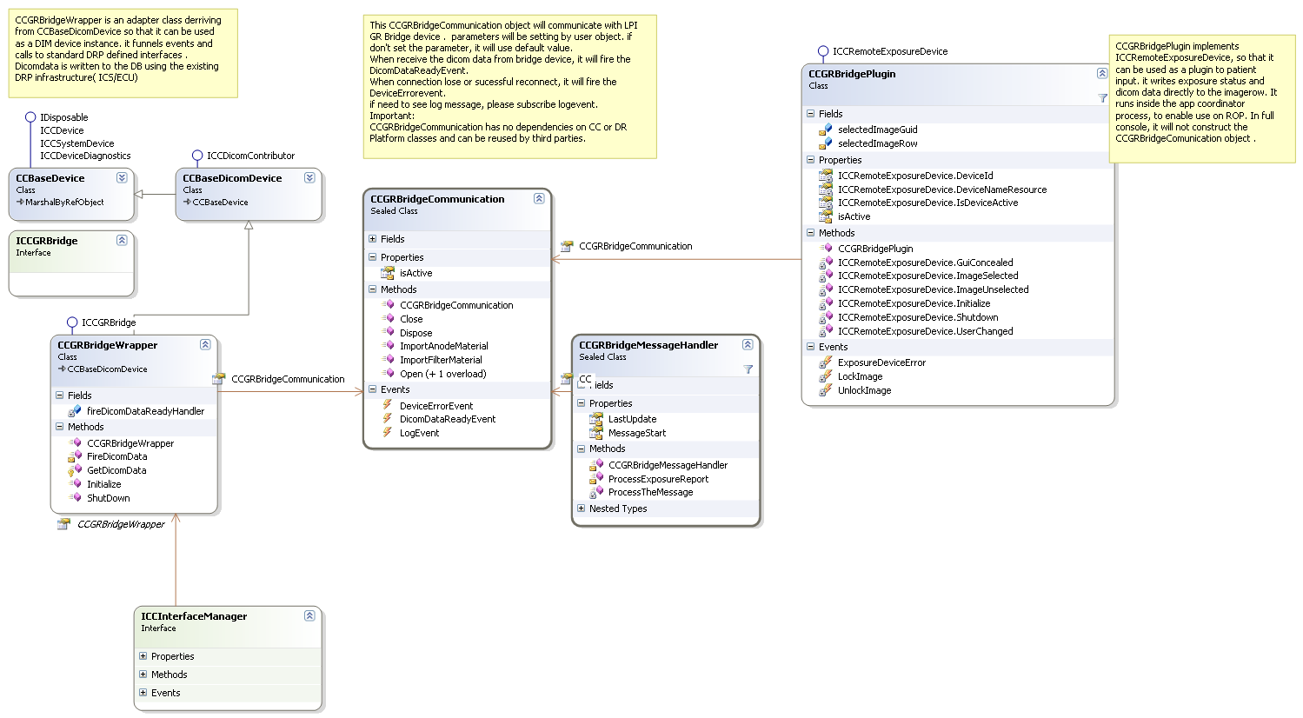

CCGRBridgeWrapper
A primary function of the class is inherited from CCBaseDicomDevice and ICCGRBridge:
ICCGRBridge is empty interface and be able to retrieve the device instance from the dim.
In initialize function, it will construct a CCGRBridgeCommunication object, after do an exposure action, CCGRBridgeWrapper will receive Dicom data from CCGRBridgeCommuntion through the dicomdataready event, then fire the Dicomdatareadyevent to event listeners of its device instance in the dim .

CCGRBridgePlugin
A primary function of the class is to implement the ICCRemoteExposureDevice interface and to decouple the bridge functionality from ICCInterfaceManager for use on the ROP. That interface has been defined in 6H4395 and presented below:
public interface ICCRemoteExposureDevice
{
void Initialize();
void Shutdown();
string DeviceId { get; }
string DeviceNameResource { get; }
bool IsDeviceActive { get; }
void ImageSelected(CCCapturePatientDS.CCImageRow theImage);
void ImageUnselected(Guid ImageGuid)
void GuiConcealed(bool concealed)
void UserChanged(CCUserChangedEventArgs args)
event LockImageEventHandler LockImage;
event LockImageEventHandler UnlockImage;
event ExposureDeviceErrorEventHandler ExposureDeviceError;
}
The ICCRemoteExposureDevice interface supports hooks for plug-in initialization, plug-in shutdown and device identification. It also provides methods for passing information to and from the plug-in. After receive the Dicom data, it will update the data to imagerow and database directly.
In the Initialize method, if the Running environment is ROP, it will constructor a BridgeCommunication object. , if the Running environment is not ROP, it cannot do anything. We can use CCServerProperties.IsRemote to determine whether a ROP environment.
After do an exposure action, CCGRBridgePlugin will receive Dicom data from BridgeCommunication through the dicomdataready event, then update the data to imagerow and database .
DeviceID and DeviceNameResource will each return a static string defined as TBD.
The Boolean indicator IsDeviceActive will return BridgeCommunication IsDeviceActive value, when the serial port is open and communicating with the LPI CR Bridge the value is true , it’s false when it is not.
Patient data (CCCapturePatientDS.CCImageRow) is passed to the CCGRBridgePlugin via the ImageSelected method. The imageRow input is used by the plug-in to update the system data base with generator settings reported via the serial link.
The ImageUnselected method indicates to the plug-in that no imageRow has been selected. The imageGUID input serves as a sanity check and should match the imageGUID indicated by the selected imageRow discussed previously.
The ImageSelected and ImageUnselected methods are used together to define a “Valid Report Window”. Any data received prior to the invocation of the ImageSelected method or after the ImageUnselected method is discarded and not included as part of an exposure report.
Neither the GuiConcealed method nor the UserChanged method have relevant processing requirements with-in the context of the LPI GR Bridge. The methods are included only to support implementation of the ICCCRRemoteExposureDevice interface.
The third event (ExposureDeviceError) is used and allows the CCGRBridgePlugin to notify the CCRemoteExposureCoordinator.
Similarly, no mechanism exists to raise either the LockImage or UnlockImage events. (This may have ripple effects within the implementation of CCActiveImageHandler). Two events (LockImage and UnlockImage) have been defined to help synchronize DR system hardware with the GUI. Neither of these events have relevance within the context of the GR Bridge. The implementation of CCGRBridgePlugin simple provides placeholders for those events to exist, it does not raise them.

BridgeCommunication
This class can communicate with LPI GR Bridge.
The Open method will open a serial port with the LPI GR Bridge. Failure to open the port will result in an attempt to open another port. Since configurations for both the Capture Console and ROP must be supported, the list of available serial ports to be used will be determined at run time. Local event handlers (character data received, port errors, pin change events) will be connected at during initialization as well.

The Close method will serve to close the serial port and disconnect the local event handlers.

DeviceID and DeviceNameResource will each return a static string defined as TBD.

The Boolean indicator IsDeviceActive will return true when the serial port is open and communicating with the LPI CR Bridge and return false when serial port cannot be opened.

The DicomDataReadyEvent event will be fire after receive LPI GR Bridge exposure data.

The event (DeviceErrorEvent) will be fired when a failure with the LPI CR Bridge has been detected or when a reconnect success with the LPI CR Bridge has been detected.

The main function of the CCGRBridgeCommunication supports a communications protocol with the LPI GR Bridge. That communication protocol has been outlined in “CR Protocol Bridge Specification – Kodak CR Console, Version 0.2, 16-OCT-06.” At its top most level, the CCGRBridgeCommunication opens a connection with the LPI Bridge and processes any Character, Error and PinChanged events using standard .Net event handling techniques. No a-priori assumptions are made as to the quantity or type of data that might be received. All serial data is processed as it is made available. When serial data is available it is parsed and assembled into a valid message. Message parsing, command constructions are implemented beneath the topmost level through CCGRBridgeMessageHandle.

Support other application.
The CCGRBridgeCommunication object can be used in other application. The application can construct the CCGRBridgeCommunication and subscribe the CCGRBridgeCommunication events, invoke the open function to start the try to communicate with LPI Bridge Device. The application can get the Dicom data via DicomDataReady event, get the error message via DeviceError event, get the log information via logevent event. If need to close the bridge connection, please invoke the close method.
The CCGRBridgeCommunication have some configurations.
    - If application wants to use port parameter other than default value, please invoke open with parameter.
    - Filter Material
This is a one (1) character field which indicates the 1st character of the filter material element name.
If user cannot import the Filter data, the CCGRBridgeCommunication will save the original value into Dicom hashtable that bridge device send out.
    - Anode Material
This is a one (1) character field which indicates the 1st character of the anode material element name.
If user cannot import the Anode data, the CCGRBridgeCommunication will save the original value into Dicom hashtable that bridge device send out.

CCGRBridgeMessageHandler
The CCGRBridgeMessageHandler formats and parses all message packets transferred between the Crbridge and the LPI GR Bridge. The general format of each message is given below:
<SOH><MsgType><Sender><STX><Payload><ETX><Checksum[2]><ETB>
Where:
<SOH> is an ASCII “Start of Header” control character.
<MsgType> is a single ASCII character from the set [PXTt-+].
<Sender> is a single ASCII character [A-Z] indicating a Sender ID.
<STX> is an ASCII “Start of Text” control character.
<Payload> is a variable length string of one or more printable ASCII characters.
<ETX> is an ASCII “End of Text” control character.
<Checksum[2]> is a two digit hex number.
<ETB> is an ASCII “End Transmission Block” control character.
In terms of a simple state machine, the CCGRBridgeMessageHandler can be represented by the following state transition matrix:
 | 1 | 2
1 | 2 | 2
2 | 1 | 2
3 | 1 | 2
Table 1 - CCGRBridgeMessageHandler State Transition Matrix
Where the events are defined as
- <SOH> Received - A Start of Header character has been received.
- <ETB> Received - An End Transmission Block character has been received
- Other Character Received – A character other than <SOH> or <ETB> has been received.
And the states are defined as:
- SearchingForSOH
- SearchingForETB
No a priori assumption is made regarding length of the received text. By convention, all characters arriving prior to the detection of an <SOH> are discarded. Characters arriving after the <SOH> are appended to a message buffer for later processing. Arrival of an <ETB> indicates the end of a message - the message can now be parsed and validated as having proper structure and checksum. In terms of a Regular Expression, a valid message can be expressed as
reMessage = new Regex(@"^\x01[XTP+-][A-Z]\x02.+\x03[A-F0-9]{2}\x17$");
Valid message blocks are subjected to further processing. Four separate message types are defined under the LPI CR Protocol Bridge Interface Specification. They are:
    - An exposure report [X]
    - A communications test [T]
    - A poll message [P]
    - A message acknowledgement [ + | - ]
Of the above message types, only the Exposure Report contains data used in send to console with fire the dicomdataready event. At present, up to twenty (20) parameters may be included as part of any Exposure Report. Each parameter shall be mapped to a specific field in the Dicom hashtable
Dicom hashtable content sample:
Key | Value
Tag_0018.0060 | 18

The twenty data items are listed in Table 2. Also listed are various fields with in the Dicom hashtable that each item maps to.
Parameter | Units | Field | Dicom Data
C00 X-Ray Machine Type | n/a | TBD
C01 Exposure Time | ms | ExposureTime | 0018,1150
C02 Source Image Distance | cm | DistanceSourceToDetector | 0018,1110
C03 Tube Voltage | kV | KVP | 0018,0060
C04 Tube Current | mA | XrayTubeCurrent | 0018,1151
M00 Magnification Factor | (percent) | EstimatedRadiographic  MagnificationFactor | 0018,1114
M01 Compressed breast thickness | mm | BodyPartThickness | 0018,11A0
M02 Exposure Mode | n/a | TBD
M04 Filter Material | (indexed) | FilterMaterial | 0018,7050
M05 Anode Material | (indexed) | AnodeTargetMaterial | 0018,1191
M06 Grid (Bucky) Presence | (Boolean) | TBD
M07 Arm Angle | (degrees) | PositionerPrimaryAngle | 0018,1510
M08 Exposure mAs | mAs | ExposureInMicroarcsecond | 0018,1152
M09 Compression Force | newtons  or Kg | CompressionForce | 0018,11A2
M10 Focus Size | um | FocalSpot | 0018,1190
M11 View (Projection) | n/a | ViewPosition | 0018,5101
M12 Sensor Position | n/a | TBD
M13 Average (organ) Dose | mGy or dGy | OrganDose | 0040,0316
M14 Entrance (skin) Dose | mGy or dGy | EntranceDose | 0040,0302
M15 Image Area Dose | mGy or dGy | ImageAreaDoseProduct | 0018,115E

Define what this application, business component, or system component provides and what problem it solves. Include any design patterns used.
Required: Include here a description of why the approach you have chosen is better than other possible approaches.
You should include discussions of the following topics:
- Important design concepts that constrain the solution options
- Major design factors and decisions
- Limitations
- Risks
- Other approaches considered (why didn’t you choose them)
- Any unresolved issues

  - Diagrams

Class Sequence Diagrams

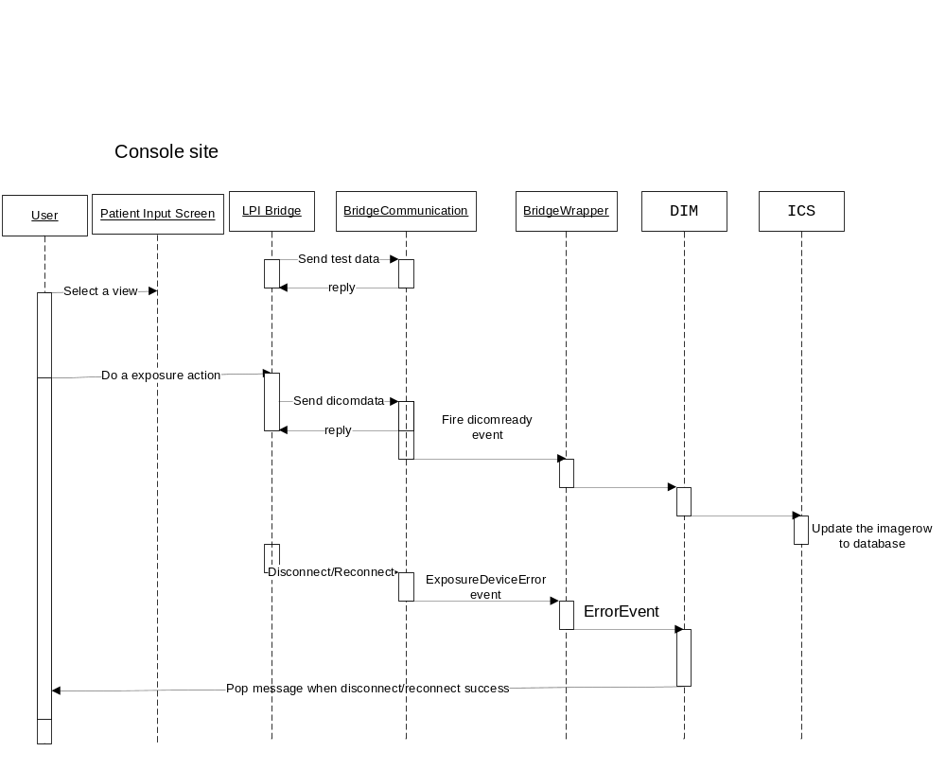
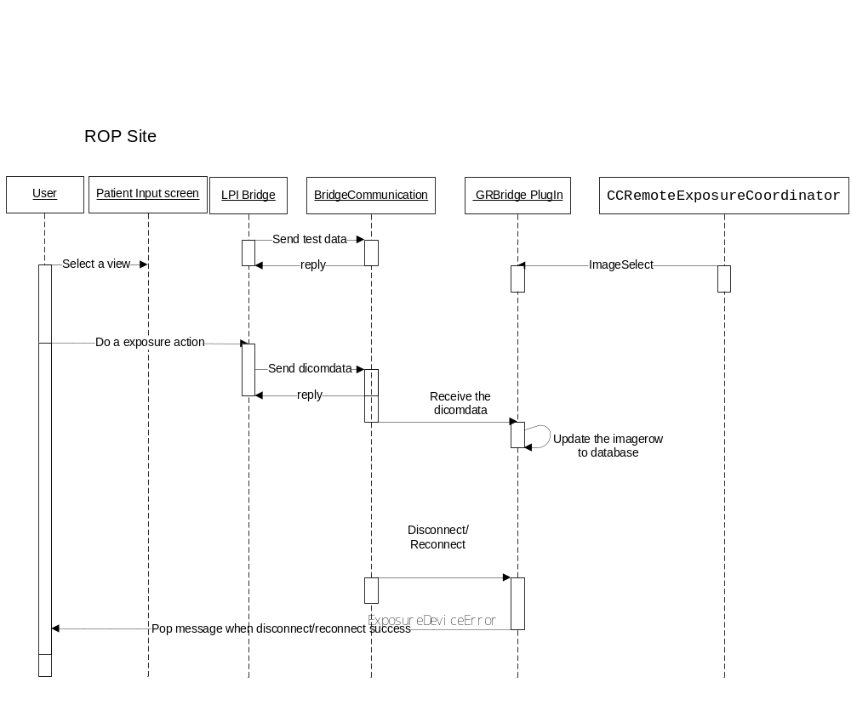

Class and Interface Definitions

  - CCGRBridgeWrapper

Description
This class inherits from CCBaseDicomDevice.

Members
Name | Description
Void Initialize () | Construct CCGRBridgeCommunication object and open it, import parameter to the CCGRBridgeCommunication object.
Void Shutdown() | Shutdown and invoke CCGRBridgeCommunication.close method.
Void DicomDataReadyEvent | After receive the Dicom data from CCGRBridgeCommunication, and then fire it.
Void DeviceError | If receive deviceerror event, fire the CCBaseDicomDevice ErrorEvent event to DIM.

  - CCGRBridgeCommunication

Description
Communicate with serial port .

Members
Name | Description
Void Open () | try to connect the serial port
Void Close() | Shutdown and disconnect the serial port
void serialPort_DataReceived(object source, SerialDataReceivedEventArgs e) | Receive data and send it to CCGRBridgeMessageHandle
void serialPort_ErrorReceived(object source, SerialErrorReceivedEventArgs e) | Receive error data and Forwards Error events to the FSM
void serialPort_PinChanged(object source, SerialPinChangedEventArgs e) | Handles the serial pin changed event
void Dicomdatareadyevent event | When receive Dicom data, fire it.
Void DeviceErrorevent event | When Device lose connection, fire it.
Void logevent event | Operation log.
Open(string portname , int baudRate, int parity, int dataBits) | try to connect the serial port with parameter
void ImportFilterMaterial( string[][] args) | FilterMaterial data will import from user and will be used in Parse bridge data to dicomdata. The parameter can get from configstore. the path is \capture\cr\crbridge\ AnodeMaterial
Void ImportAnodeMaterial(string[][] args) | AnodeMaterial data will import from user and will be used in Parse bridge data to dicomdata. The parameter can get from configstore, the path is \capture\cr\crbridge\ FilterMaterial.
  - CCGRBridgeMessageHandler

Description
The CCGRBridgeMessageHandler formats and parses all message packets transferred between the CCGRBridgeCommunication and the LPI GR Bridge.

Members
Name | Description
Void ProcessExposureReport() | Send Exposure data to console.
void SendReplyMessage(Char MessageType, String MessagePayload) | Send Control Characters to LPI GR Bridge
Void ProcessNewCharacters(String someText) | Summary the message from Bridge Device and go to flow it by control character.
Void SendDicomdata(CCGRBridgeEventArgs args) | Transfer the Dicom string to Dicom hashtable , send Dicom hashtable out .
Each class in this section should be described enough to evaluate the class diagrams and scenarios.
It is assumed that detailed documentation of method signatures, their return types and their parameters will be documented in source code. This information could be extracted in some other form such as a Windows Help file.
If that level of detail is not included here, the document containing that information could be referenced in section 1.3.
List important class/interface members with a brief description of data types, parameters, return values, and purpose.
List important class/interface members with a brief description of data types, parameters, return values, and purpose.

Module Definitions
Classes and interfaces are packaged into .NET assemblies, libraries or other DLLs.
List each module that is used to package this design.

  - <Enter Module Name Here>
Describe the package or module and describe what role it plays.

User Interface
N/ASummarize here any information given to, or supplied by, the user through a human interface. This section could include startup commands and command line switches for command line driven programs. If your design includes a Graphical User Interface (GUI) then this section should identify in detail what the presentation layer or user interface should look like. Use techniques like storyboards and screen shots to document each user screen and its use. Illustrate the flow with use cases that show how a user accomplishes sample tasks.

Provide a brief description of this User interface element, it could be a GUI screen or dialog or even a set of command line arguments for command line driven applications.
Provide a screen shot if one is prototyped and appropriate for this element.
Then describe any pre-conditions that should be met before this user interface interaction occurs along with any post-conditions or change in the state of the system when this element is completed.
Describe the error handling that is in use for this element.
List all new or modified fields or other controls, if appropriate, along with any range information or limitations that a coder may find useful when implementing the GUI element. The sample text needs updating.

Common and Environmental Issues
  - Build Environment
  - Run-time Environment
Support all V5-program approved CR scanner models:
CR0825,
CR0850,
CR0850A,
CR0875,
CR0876,
CR0975
Non-supported scanner models:
CR scanner models:
CR0500,
CR0800,
CR0900,
CR0950,
CR0950A
Orex (all models)
ACR (all models)
Support all V5-program approved PC platforms (e.g. 3.0GHz).
  - Network Environment
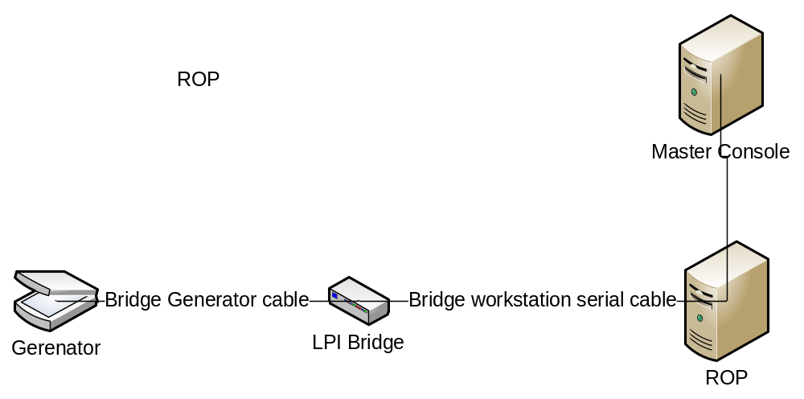

Console:
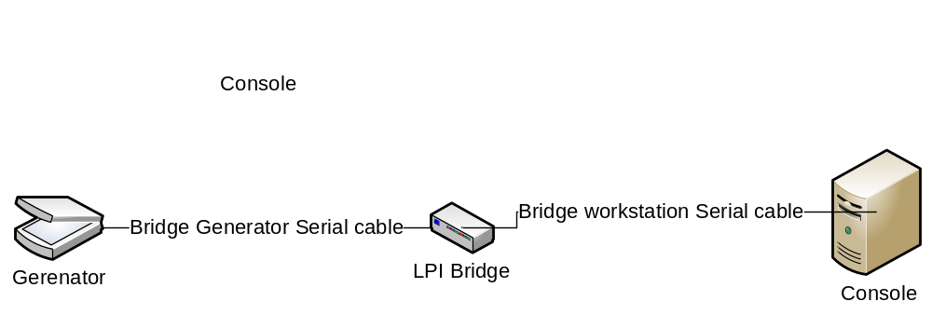

  - Software Dependencies
Need dot net framework4.0 support.
CCGRBridgeWrapper Dependencies:
EK.Capture.DR.Devices.Interfaces.Common
EK.Capture.DR.Devices.Interfaces.CCSystem
EK.Capture.DR.Devices.Common
EK.Capture.DR.Devices.Enums
CCGRBridgePlugin dependencies:
Only need dotnet framework assembly.
CCGRBridgeCommunication dependencies:
EK.Capture.DR.Devices.Interfaces.Common
  - Computer Hardware Platform
N/A
  - Memory Management
N/A
  - Data Storage and Management
N/A
  - Performance
N/A
  - Diagnostics
N/A.Describe any diagnostic (i.e. self-test) features that this component may have.

  - Security
N/A
  - Licensing
N/A
  - Internationalization
Refer to the Capture Console Internationalization Strategy Document.
When CCGRBridgeCommunication fire deviceerror event, CCGRBridgeCommunication don’t transfer the error message to local language. The subscribe class should transfer the error message to local language.
  - Backup & Restore
N/A
  - Logging
Refer to the Capture Console Logging Strategy Document.
All data that received from LPI Bridge will be logged using info level.
All data that send to DIM will be logged using info level.

  - Device Interaction
The GRBridgeCommunication will interact with the LPI GR Bridge as documented in the CR Protocol Bridge Interface Specification (Version 0.2), dated 16-Oct-06.
Describe any impacts on performance that this software may have. For any performance requirements in the PRS, describe how these criteria are to be met.
N/ADescribe any interaction with hardware devices that is primary to the component’s purpose. Describe any secondary interaction with hardware devices that has an impact on the design.

  - Software Configuration
Config store should add these definitions and these definitions will add on setup:
- Add a plugin definition
\capture\System\Hardware\RemoteExposureDevices\DeviceLoadData
- Add a device named CCGRBridgeWrapper
\capture\DR\Equipment\DeviceInstances
- Add parameter for CCGRBridgeCommunication
\capture\cr\crbridge\ ( bate rate…)
\capture\cr\crbridge\ AnodeMaterial
\capture\cr\crbridge\ FilterMaterial

  - Service Design
N/A

Evolution Plan
N/A

Test Cases
Refer to the V5 LPI CR Bridge-7H6656 document.

Connected with LPI Bridge and Barcode reader via USB Port

ID | Action | Expected Results | Pass/Fail  Defect ID
 | Setup LPI GR Bridge for ROP according to:  Installation Instructions for the  X-Ray Interface, | The LPI GR Bridge is configured.
 | Record the type of cabling used for OUTPUT Cable to the Console/ROP: | The USB to RS-232 Adapter connections are used with the ROP and CR PC HP 5700.
 | Connect the Barcode reader via USB port | Can be found in device manager in windows.
 | Verify | The ROP/CR shall communicate with the gateway via a serial communication interface. Since the ROP does not contain a standard serial port a USB to Serial converter shall be used.  Barcode reader also can use.

Design Notes
N/A

